H.T No
Regulations:
A17

Sreenidhi Institute of Science and Technology
(An Autonomous Institution)
Code No: 6AC41 Date: 17-Aug-2023 (FN)

B.Tech II-Year II- Semester External Examination, Aug - 2023 (Supplementary)
Elements of Electrical Engineering (CSE and IT)

Time: 3 Hours Max.Marks:75

Note: a) No additional answer sheets will be provided.
b) All sub-parts of a question must be answered at one place only, otherwise it will not be valued.
c) Missing data can be assumed suitably.

Bloom's Cognitive Levels of Learning (BCLL)

Remember | L1 | Apply | L3 | Evaluate | L5
Understand | L2 | Analyze | L4 | Create | L6

Part - A Max.Marks:25
Answer all QUESTIONS

 |  | BCLL | CO(s) | Marks
1 | Estimate values of the resistors, when two resistors are connected in parallel, their equivalent resistance is 2Ω, and in series, their equivalent resistance is 9Ω. | L2 | CO1 | [2M]
2 | Define “J” operator? and How it is used in electrical circuit analysis. | L1 | CO2 | [2M]
3 | Recall voltage regulation in transformer and its significance. | L1 | CO3 | [2M]
4 | Define Transformer. | L1 | CO4 | [2M]
5 | Discuss How do you make Single-Phase Induction Motor Self-Starting. | L2 | CO5 | [2M]
6 | Describe the controlling torque. | L1 | CO6 | [3M]
7 | Define maximum power transformation theorem. | L1 | CO1 | [3M]
8 | List the Losses In Transformer. | L1 | CO4 | [3M]
9 | Define Slip. | L1 | CO5 | [3M]
10 | State Faraday’s law of electromagnetic induction. | L1 | CO2 | [3M]
Part – B Max.Marks:50
ANSWER ANY FIVE QUESTIONS. EACH QUESTION CARRIES 10 MARKS.

 |  |  | BCLL | CO(s) | Marks
11. | a) | Solve the current in 10Ω resistor by using superposition theorem.  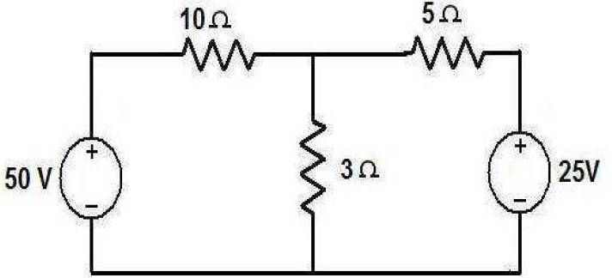 | L3 | CO1 | [5M]
 | b) | If the 12Ω resistor draws a current of 1A as shown in the figure, Compute the value of resistance R is  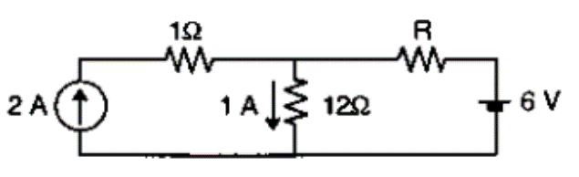 | L3 | CO1 | [5M]
12. | a) | Examine the form factor and peak factor of full wave rectified sine wave shown in figure  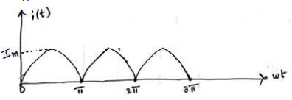 | L3 | CO2 | [5M]
 | b) | A coil of resistance 20 ohms and inductance 100mH is connected in series with a capacitance of 40 microfarad across 100 V, 50 Hz ac supply. Solve (i)impedance (ii) current | L3 | CO2 | [5M]
13. | a) | Compute the EMF equation of DC generator. | L3 | CO3 | [5M]
 | b) | Sketch & illustrate the types of DC Generator with their equations. | L3 | CO3 | [5M]
14. | a) | Derive the Equivalent circuit diagram of a single phase transformer and explain each parameters. | L3 | CO4 | [5M]
 | b) | The test results of 2.5kVA, 230/115V single-phase transformer are as follows:  OC Test : 115V, 1.2A, 60W  SC Test : 12V, 10.86A. 120W Find efficiency at full load, 0.8 pf | L2 | CO4 | [5M]
15. | a) | Solve the phase relations between line and phase quantities in a 3-ϕ balanced Star connected system | L3 | CO5 | [5M]
 | b) | A three phase balanced delta load of (4+j8)Ω is connected across a 400V,3-ϕ balanced supply. Solve the phase currents and line currents. Assume the phase sequence RYB | L3 | CO5 | [5M]
16. | a) | Sketch and Explain the operating principle of Moving Iron type instrument. | L2 | CO6 | [5M]
 | b) | List the advantages and disadvantages of Moving instrument. | L3 | CO6 | [5M]
17. | a) | State and explain Kirchhoff’s Laws | L2 | CO1 | [4M]
 | b) | What is the principle of mutual induction? | L1 | CO2 | [3M]
 | c) | List the applications of DC Shunt and DC series Motor. | L1 | CO3 | [3M]
18. | a) | Differentiate Ideal vs Practical Transformer. | L4 | CO4 | [4M]
 | b) | A 3-φ 4 pole induction motor is supplied from 3φ 50Hz ac supply. Compute  (i) synchronous speed  (ii) rotor speed when slip is 4% | L2 | CO5 | [3M]
 | c) | Difference between Moving Coil and Moving Iron Instrument. | L2 | CO6 | [3M]

-- 00 -- 00 –

